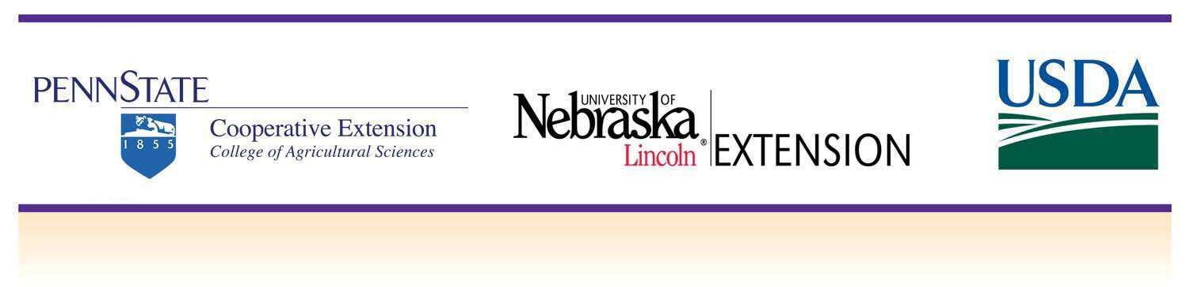

EARLY CHILD EDUCATION

Childcare & Youth Training and Technical Assistance Project (CYTTAP)
The Childcare and Youth Training and Technical Assistance Project (CYTTAP) is being conducted by the University of Nebraska–Lincoln Extension with Penn State Extension in partnership with the U. S. Department of Defense. The focus of this three year project is to provide training and technical assistance to early childhood professionals in 20 states who care for young children of off installation military families. Military families face unique challenges and have a growing need to access quality community‐based child care. Trainings offered include:

Better Kid Care OnDemand
Online professional development for childcare providers through online distance education, resources, e‐newsletters, mentoring and much more. Better Kid Care’s new On Demand Distance Education system provides professional development anytime you are ready to learn!

Better Kid Care Instructor Modules
It is easy for instructors to offer research‐based 2‐hour workshops from Better Kid Care, without spending a lot of time on preparation. The research and development is done and all the instructors need to do is the delivery. Each module includes an Instructor’s Manual, DVD with video, camera‐ready handouts, and instructions for participant activities.

IMIL (I Am Moving, I Am Learning)
This compilation of resources helps childcare providers learn and practice strategies for increasing the quantity of time children spend in moderate to vigorous physical activity (MVPA) during daily routines. Ways to improve the quality of structured movement experiences for children intentionally facilitated by adults will be shared as well as techniques for promoting healthy nutrition choices for children every day.

Preventing Child Abuse and Neglect (PCAN)
Preventing Child Abuse and Neglect (PCAN) is ZERO TO THREE’s training curriculum that provides the knowledge, skills, and strategies child care providers need to partner with parents in order to help prevent child maltreatment. This training focuses on relationship‐based and reflective facilitation; understanding and preventing maltreatment of infants and toddlers, and helping directors to support staff in establishing effective relationships with families.

Rock Solid Foundations: Promoting Social and Emotional Competence of Young Children
Based on The Pyramid Model, this training utilizes research based strategies and resources from the Center on Social and Emotional Foundations of Early Learning (CSEFEL), focusing on the social emotional development and school readiness of young children birth to age 5.

SCHOOL AGE EDUCATION

Learn, Grow, Eat, and Go (Junior Master Gardener)
Learn, Grow, Eat & GO! is the new research-based curriculum of the International Junior Master Gardener® Program. This multifaceted garden, nutrition, and physical activities curriculum is features 20 hands-on lessons for a 10-week program. Students will learn and understand how plants provide for people’s needs. In addition to gardening, fresh vegetable tasting/evaluation, simple recipe demos, and physical activities that research shows can improve on-task behavior and academic performance are included.

Essentials Elements

What is positive youth development? How can adults facilitate positive youth development in children and youth? Learn about and understand the importance of positive development by presenting the eight elements that are vital to the development of youth. Included will be discussion and hands-on activities to help create the combination of the elements that creates a positive environment for youth development.

Junk Drawer Robotics

Guide school age youth through the circuitry and wiring of their very own robots! Youth can build skill through the activities of Junk Drawer Robotics in science, engineering, and technology by engaging youth to use the processes and approaches of science; the planning and conceptual design of engineering; and the application of technology.

Click2Science
Click2Science provides resources front‐line staff can use to increase their skills in engaging youth in STEM. Click is based on 20 skills related to Planning STEM Experiences, Interacting with Youth During STEM, and Building STEM skills in Youth

Power of the Wind
The Power of the Wind Curriculum is about the wind and its uses. Youth work with members of a team to design, create, build, and test a wind powered devices and are given opportunities to explore wind as a potential energy source in their community.

Reading Makes Cents
Reading Makes Cents is a collection of activities developed around exemplary children’s literature that has money as a theme. The literature explores ideas, activities, and strategies that help children learn how to earn, save, share, and spend money. Children's literature provides a rich diversity of settings, people, income levels, relationships, and ethnic backgrounds, religions, and holidays, all related to money messages and learning.

Tools of the Trade II ‐ Inspiring Young Minds to be Science, Engineering, and Technology Ready for Life
Tools of the Trade II is a staff‐development guide for afterschool program frontline staff and youth workers on incorporating science, engineering, and technology (SET) into afterschool programming. Tools II uses a hands‐on, interactive skill‐building approach and provides tools drawn from research and best practices to help afterschool staff enhance science education.

By building upon the existing resources and early care initiatives in each state, the goal of this project is to increase the number of military children ready for school and demonstrate improved educational competencies, resulting in the long‐term outcome of military‐ready soldiers who are confident that their children have access to high quality, stable child care.

Extension programs and employment are available to all without discrimination.
Evidence of noncompliance may be reported through your local Extension office. This material is based upon work supported by the National Institute of Food and Agriculture, U.S. Department of Agriculture, and the U.S. Department of Defense under Award No. 2009‐48667‐05833.
Developed in partnership with University of Nebraska–Lincoln Extension and Pennsylvania State University Extension
Any opinions, findings, conclusions, or recommendations expressed herein are those of the author(s) and do not necessarily reflect the view of the
U.S. Department of Agriculture. 4‐13‐2015

