Click2Science

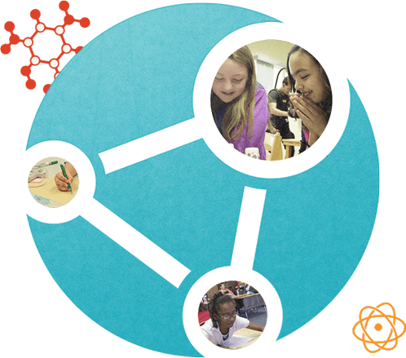 Dates/Location/Time of Training

Click2Science is an interactive, professional development site for trainers, coaches, site directors and frontline staff/volunteers working in out-of-school time STEM programs, serving children and youth.
Click2Science provides resources front-line staff can use to increase their skills in engaging youth in STEM. Click is based on 20 skills related to Planning STEM Experiences, Interacting with Youth During STEM, and Building STEM skills in Youth.
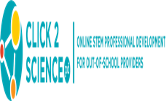
Trainers of this program will conduct trainings for
child care providers in the targeted military‐rich
counties in for the grant.

For more information, please contact:
CYTTAP Educator Name
Address
Phone
Email

To register, go to http://extension.psu.edu/cyttap

