**Essential Elements of Youth   
Development Programs  
Key Ingredients for Program Success**

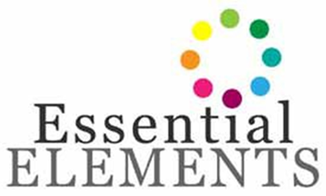 **Dates/Location/Time of Training**

The purpose of this curriculum is to provide the professional youth worker with knowledge, information, and understanding of working with you in positive, supportive, and productive environments. Front-line youth professionals will gain skills interacting with you and providing opportunities for them to learn, succeed, and become confident.

What is positive youth development? How can adults facilitate positive youth development in children and youth? Learn about and understand the importance of positive development by presenting the eight elements that are vital to the development of youth. Included will be discussion and hands-on activities to help create the combination of the elements that creates a positive environment for youth development.



Trainers of this program will conduct trainings for

child care providers in the targeted military‐rich

counties in for the grant.

For more information, please contact:

CYTTAP Educator Name

Address

Phone

Email

To register, go to <http://extension.psu.edu/cyttap>