**Junk Drawer Robotics**

**Dates/Location/Time of Training**

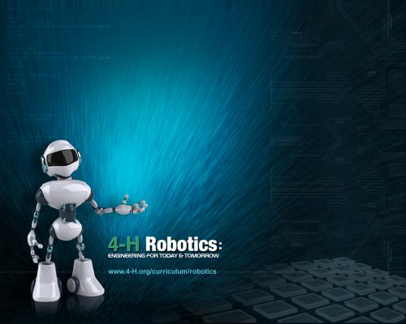

Guide school age youth through the circuitry and wiring of their very own robots! Youth can build skill through the activities of Junk Drawer Robotics in science, engineering, and technology by engaging youth to use the processes and approaches of science; the planning and conceptual design of engineering; and the application of technology.

Youth will learn to think like a scientist, communicate like an engineer, and build like a technician.

Trainers of this program will conduct trainings for child care providers in the

Targeted military-rich counties for the grant.



For more information, please contact:

CYTTAP Educator Name

Address

Phone

Email

To register, go to <http://extension.psu.edu/cyttap>