Learn, Grow, Eat, and Go (Junior Master Gardener)

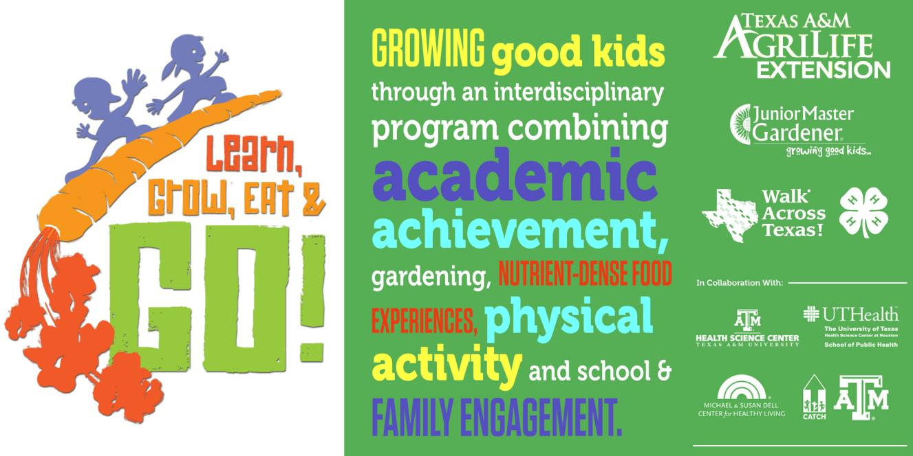 Dates/Location/Time of Training

Learn, Grow, Eat, and Go curriculum, LGEG for short, is a 10-week unit of study that is hands-on, multifaceted, and academically rich for youth in grades 3-5. LGEG was developed for a research project in which Texas A& M Agrilife Extension contributed and is a part of the International Junior Master Gardener Curriculum. LGEG is focused on getting children to participate in activities where they can learn important science, math and language arts concepts and at the same time be more physically active, improve healthy eating habits and have fun. LGEG activities also promotes leadership and responsibility in children. It is comprised of 20 lessons which also feature food exposures, gardening, and physical activities.

LGEG components are -
- Learn - Lessons
- Grow - Activities
- Eat - Exposure
- Go - Activity

Trainers of this program will conduct trainings for
child care providers in the targeted military‐rich
counties of the CYTTAP grant.

For more information, please contact:
CYTTAP Educator Name
Address
Phone
Email

To register, go to http://extension.psu.edu/cyttap

