**Reading Makes Cents**

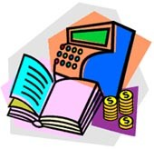 **Dates/Location/Time of Training**

Reading Makes Cents is comprised of a collection of activities developed around exemplary children’s literature that has money as a theme. The selected children's literature explores ideas, activities, and strategies that help children learn how to earn, save, share, and spend money. Children's literature provides a rich diversity of settings, people, income levels, relationships, ethnic backgrounds, cultures, religions, holidays, intergenerational friendships all related to money messages and learning.

Lessons include:

* Managing Money
* Spending Money
* Saving Money
* Sharing Money
* Earning Money



* Borrowing Money

Trainers of this program will conduct trainings for

child care providers in the targeted military‐rich

counties in for the grant.

For more information, please contact:

CYTTAP Educator Name

Address

Phone

Email

To register, go to <http://extension.psu.edu/cyttap>