**CYTTAP School Age (OST) Curriculum Options**

**Reading Make Cents**

**Power of the Wind**

**Essential Elements**

**Learn, Grow, Eat, and Go (Junior Master Gardener)**

* Training of Trainers - Available to all states
  + Trainers would participate in a face-to-face training. Those attending the training would get the curriculum and a training kit at no cost.
  + TOTs Training
    - Reading Makes Sense - ½ day
    - Power of the Wind - ½ day
    - Essential Elements - ½ day
    - Learn, Grow, Eat and Go - 6 hours
* Direct Provider Training
* Trainers would provide F2F direct provider training in at least two locations in designated counties.  Trainers would be eligible to receive curriculum for the training, at no cost, for each registered front-line staff.

**Click2SciencePD**

* Training of Trainers - Available to all states. Trainers would participate in training on how to utilize Click resources.
* Direct Provider Training
  + Trainers would provide F2F direct provider training in at least two locations in targeted counties.

**Tools of the Trade II**

* Training of Trainers - Available to all states
  + Trainers would participate in a two-day face-to-face training. Those attending the training would get the curriculum at no cost.
* Direct Provider Training
  + Trainers would provide F2F direct provider training in at least two locations in designated counties.

**Reading Make Cents**

Reading Makes Cents - <http://www.4-h.org/resource-library/curriculum/4-h-reading-makes-cents/activity-guide/>

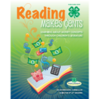

Reading Makes Cents is comprised of a collection of activities developed around exemplary children’s literature that has money as a theme. The selected children's literature explores ideas, activities, and strategies that help children learn how to earn, save, share, and spend money. Children's literature provides a rich diversity of settings, people, income levels, relationships, ethnic backgrounds, cultures, religions, holidays, intergenerational friendships all related to money messages and learning.

**The Power of the Wind**

The Power of the Wind: <http://www.4-h.org/resource-library/curriculum/4-h-the-power-of-the-wind/>

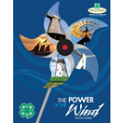

The Power of the Wind Curriculum is about the wind and its uses. Youth work with members of a team to design, create, build, and test a wind powered devices and are given opportunities to explore wind as a potential energy source in their community.

**Click2SciencePD**

Cick2Science: <http://www.click2sciencepd.org>

Click2Science provides resources front-line staff can use to increase their skills in engaging youth in STEM. Click is based on 20 skills related to Planning STEM Experiences, Interacting with Youth During STEM, and Building STEM skills in Youth.

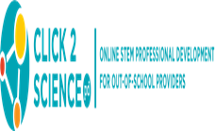

**Tools of the Trade II**

Inspiring Young Minds to be Science, Engineering, and Technology Ready for Life



Tools of the Trade II is a staff-development guide for afterschool program frontline staff and youth workers on incorporating science, engineering, and technology (SET) into afterschool programming. Tools II uses a hands-on, interactive skill-building approach and provides tools drawn from research and best practices to help afterschool staff enhance science education

**Learn, Grow, Eat, and Go**

Learn, Grow, Eat, and Go: <http://jmgkids.us/lgeg/>

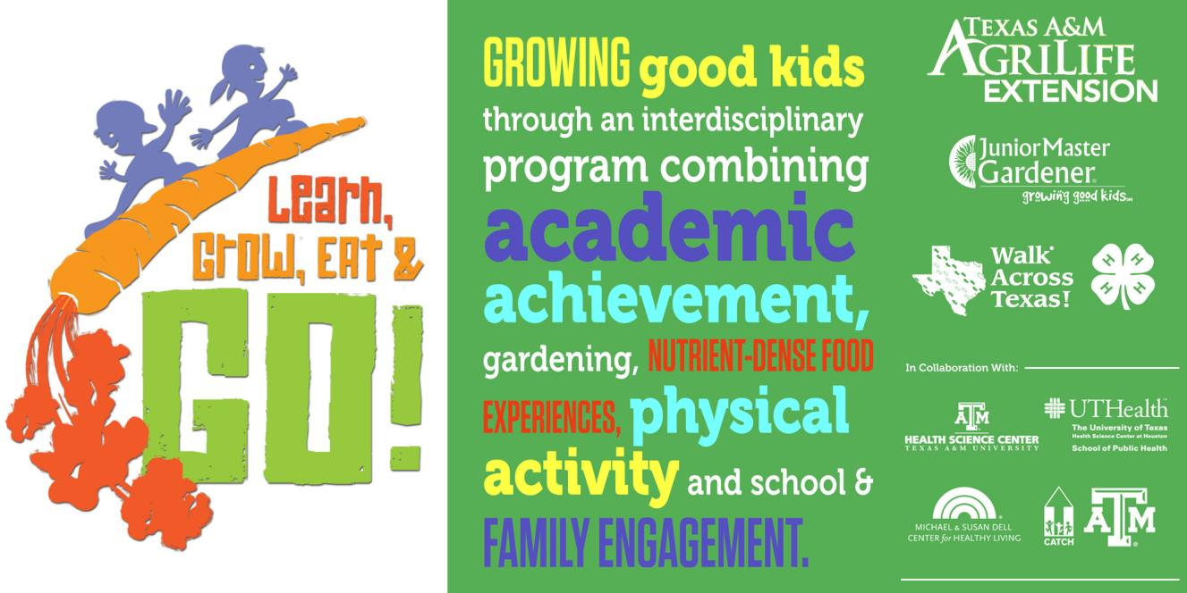

Learn, Grow, Eat & GO! is the new research-based curriculum of the International Junior Master Gardener® Program.  This multifaceted garden, nutrition, and physical activities curriculum includes twenty hands-on lessons in a 10 week program. Students will understand how plants provide for people’s needs. Gardening, fresh vegetable tasting/evaluation, simple recipe demos, and physical activities that research shows can improve on-task behavior and academic performance are featured.

|  |
| --- |
|  |